Easter Holidays | Read | Watch | Listen/Do/Play
Week 1 (6th April – 12th April) | Conservation is all about preventing the loss of or damage to the wildlife. A main part of conservation is tracking animals and detecting invading species.  Amazingly, dogs are now being used for these roles!  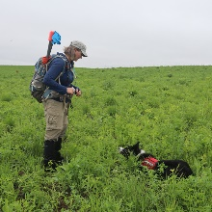  Read more below:  https://www.sciencenewsforstudents.org/article/conservation-is-going-to-the-dogs | David Attenborough is one of the most famous Conservationists and is classed as a British National Treasure.  He has presented numerous programmes highlighting issues in the natural word and celebrating natural events.  Below is a link to all of his box sets on BBC iPlayer.  https://www.bbc.co.uk/iplayer/group/p06m42d9  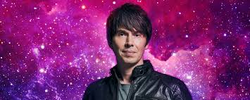  Another British Scientist is Professor Brian Cox, who has been interviewing some fantastic scientists around the world. His programme is also on iPlayer.  https://www.bbc.co.uk/iplayer/episodes/p07qf0vz/people-of-science-with-professor-brian-cox | What does DNA stand for?  DNA is short for deoxyribonucleic acid.  What is DNA made of?  DNA is a long thin molecule made up of something called nucleotides. There are four different types of nucleotides: adenine, thymine, cytosine, and guanine. They are usually represented by their first letter:  A- adenine  T- thymine  C - cytosine  G - guanine  Holding the nucleotides together is a backbone made of phosphate and deoxyribose. The nucleotides are sometimes referred to as "bases".  You can make your own model of DNA here:  https://www.rsb.org.uk/images/pdf/Sanger_DNA_Handout.pdf
Week 2 (13th April – 19th April) | 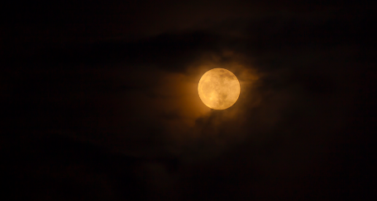  Werewolves…are they real?!  Spoiler.. they are not.  However, research has found that the moon does affect people and how they live their lives!  https://www.sciencenewsforstudents.org/article/does-moon-influence-people | As a species we have only ever been to the moon, and we have never had the opportunity to visit other planets.  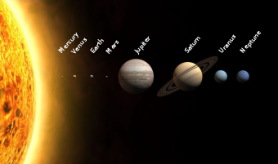  However, Professor Brian Cox has “travelled” across the solar system. Looking at all the mysteries and finding interesting and surprising facts.  https://www.bbc.co.uk/iplayer/episodes/p07922lr/the-planets | Not many people know that comedian Dara O Briain is also hooked on Science and studied Mathematical Physics.  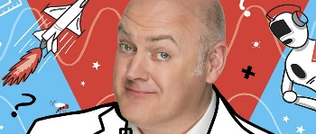  He recently released a book all about the science world beyond our eyes. Below is a podcast where Dara talks about how we Science is communicated with students, where his passion for science came from and his career.  https://www.sciencefocus.com/science/finding-the-fun-in-science-dara-o-briain/

