Easter Holidays | Read | Watch | Listen/Do/Play
Week 1  (6th April –  12th April) | 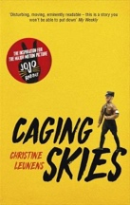  Caging Skies by Christine Leunens – the inspiration for the award-winning film ‘Jojo Rabbit’, winner of Best Adapted Screenplay at the 2019 Academy Awards.  This extraordinary novel is seen through the eyes of Johannes, an avid member of the Hitler Youth in the 1940s, who discovers his parents are hiding a Jewish girl called Elsa behind a false wall in their large house in Vienna. Caging Skies is an existential battle of moral and ethical extremes – definitely one to add to the ‘Reading List’ this Easter!  You can read a sample of the novel here: https://www.overdrive.com/media/540453/caging-skies  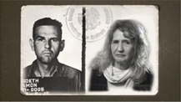  Have you ever wondered how the descendants of Nazi war criminals are coping with the legacy their ancestors left behind? Here is a really interesting article which follows the memories and lives of the descendants of Himmler, Goering, Goeth and Hoess – names that still have the power to evoke the horrors of Nazi Germany:  Nazi legacy: The troubled descendants.  https://www.bbc.co.uk/news/magazine-18120890 | You can still catch all 8 episodes of His Dark Materials on BBC iPlayer – BBC’s first series based on Philip Pullman’s award-winning novel Northern Lights. Northern Lights is the first novel that forms the trilogy, His Dark Materials, and is a thrilling tale of adventure, ambition, fantasy and deceit. The story is centred around a brave, tenacious young girl, Lyra Belaqua, who travels to the Northern Lights in a bid to uncover the truth. https://www.bbc.co.uk/iplayer/episodes/m000b1v2/his-dark-materials  The clip below is a fantastic podcast interview between Philip Pullman, the author of the Book of Dust trilogy, and Adam Buxton, about the second book, The Secret Commonwealth.  https://player.fm/series/the-adam-buxton-podcast/ep102-phillip-pullman  The next clip is of another interview between the BBC and Philip Pullman. Pullman discusses the theme of the book, as well as the initial struggles he had adapting his story for the small screen.  https://www.bbc.co.uk/programmes/p07s8824 | 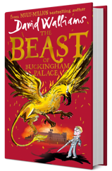  David Walliam’s new book, The Beast of Buckingham Palace, is his most epic adventure ever! The novel tells the story of Prince Alfred, a poorly and bookish child, who has never left the safety of Buckingham Palace. When something terrible begins to stalk the rooms and corridors in the dead of night, it is up to Alfred to muster up the courage to embark on an epic quest to save the people he loves… and the entire world!  You can listen to this audiobook for FREE on audible.co.uk.  The next link will direct you to 14 Literary Podcasts for Every Type of Book Person: https://electricliterature.com/14-literary-podcasts-for-when-your-hands-are-too-full-to-read/ You will find a podcast to suit any genre, here!  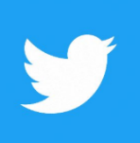  Please follow @englishatMA on Twitter to keep an eye on exciting writing and reading challenges to do during the holidays
Week 2  (13th April –  19th April) | 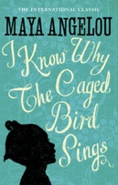  I Know Why the Caged Bird Sings is Maya Angelou’s debut memoir, and has become a beloved classic worldwide. As a black woman, she has known extreme poverty, trauma and prejudice, but also hope, joy, achievement and celebration.  Barack Obama commented that Angelou’s memoir paints a portrait of ‘a brilliant writer, a fierce friend and a truly phenomenal woman’.  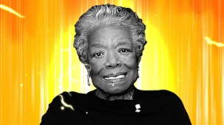  You can read this book with Amazon’s Free Kindle App on any smartphone or smart device.  Angelou’s memoir is now the basis of a major Radio 4 drama, which can be found here: https://www.bbc.co.uk/programmes/b0b7mg80/episodes/guide  Finally, you can browse through a variety of exciting titles here: https://www.juggernaut.in  This website allows you to read a wide selection of material, online. There is also an extensive collection of 19th century classics to indulge in, here: https://www.juggernaut.in/search?&q=*:*&page=1&per_page=20&filters=[{%22book_categories.tag_id%22:[%22733b26a54ec24a7ca5a9c1696088343a%22]}] Enjoy! | 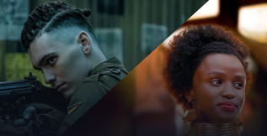  If you enjoyed reading the Noughts & Crosses series by British author Malorie Blackman, you will love the new, 6-episode series released by the BBC last month. Set in a dystopian London, star-crossed lovers, Sephy and Callum, attempt to breach the divide between the black elite and the white underclass. Combining themes of greed, race, terrorism, and love, this series is certainly one to watch! You can find all episodes on BBC iPlayer:  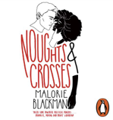  https://www.bbc.co.uk/iplayer/episodes/p082w992/noughts-crosses  You can also listen to the audiobook of Noughts and Crosses FREE on audible.co.uk.  Media Studies: If you’re particularly interested in documentaries, Side by Side investigates the history, process and workflow of both digital and photochemical film creation. It features legends of cinema such as David Fincher, Martin Scorsese and Keanu Reeves:  https://www.youtube.com/watch?v=Lly_iRGVB3U | Adventure Writing:  Grimm & Co will be providing activities to support and inspire YOU to write your own adventure story to be submitted to a global competition!  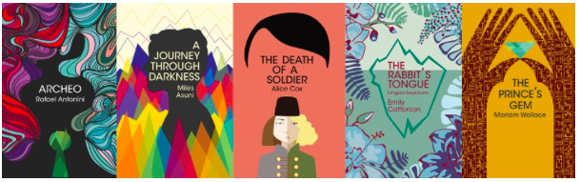  The Author of Tomorrow is designed to find the adventure writers of the future. Part of the Wilbur Smith Adventure Writing Prize, this is an annual competition open to young people across the world who have completed a short piece of adventure writing in English.  The Author of Tomorrow is accepting submissions from 5th March - 5th May 2020. There are substantial prizes to be won! For more information, visit https://www.wilbur-niso-smithfoundation.org/index.php/awards/author-of-tomorrow or contact Miss Bailey!  Please follow @englishatMA on Twitter to keep an eye on exciting writing and reading challenges to do during the holidays.
