Easter Holidays | Read | Watch | Listen/Do/Play
Week 1 (6th April – 12th April) | GPS (Global Positioning System) is one of the most important inventions on the 20th Century, and an essential tool for geographers! Nowadays most mobile phones have a GPS reciever, allowing us to find out in instant our location and allowing others to track our movement.  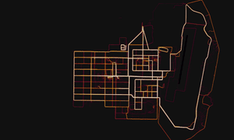  This is all very useful, but what happens when it goes wrong? In 2018 fitness tracking app Strava hit the headlines when it was revealed that is was accidentally giving away the locations of secret military bases around the world! Find out more here:  https://www.theguardian.com/world/2018/jan/28/fitness-tracking-app-gives-away-location-of-secret-us-army-bases  https://www.wired.com/story/strava-heat-map-military-bases-fitness-trackers-privacy/ | 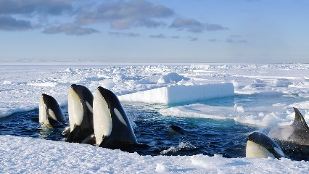  With the Coronavirus taking up nearly every minute of air-time in the news, it is easy to think that certain events such as global warming have simply ‘finished’ or disappeared. This, of course, is not the case. In this documentary David Attenborough journeys to the poles to investigate what rising temperatures will mean for the people and wildlife that live there, and for the rest of the planet.  https://www.bbc.co.uk/iplayer/episode/b00zj39j/frozen-planet-7-on-thin-ice | Can you identify these world cities from their density maps alone? It is harder than you think! Put your human geography minds to the test and see how well you do.  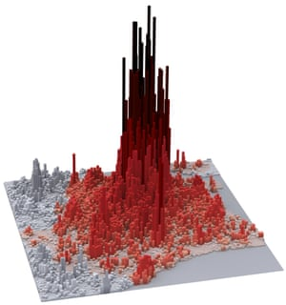  https://www.theguardian.com/cities/2019/mar/19/quiz-identify-world-cities-density-maps-alone  Please follow @MaltbyGeography on Twitter to keep an eye on more things to do during the holidays.
Week 2 (13th April – 19th April) | 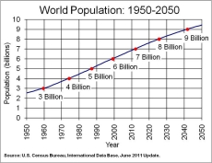  Global population is increasing. By current estimates it is likely to reach the next major milestone – 8 billion – by 2024. This poses many challenges for societies, economies and cultures. These two articles explore some of the consequences of global population growth.  https://www.theguardian.com/world/2019/jul/07/africa-birth-control-global-population-crisis  https://edition.cnn.com/2019/07/11/world/world-population-day-trnd/index.html | 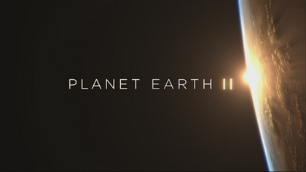  The entire series of Planet Earth II is currently on iPlayer. Watch it! You may have seen some episodes in class so chose other episodes which catch your interest. Planet Earth II is ground-breaking in the way it tells the stories of animals in an interesting and engaging way, combined with state of the art technology to capture amazing images of some of the world’s most amazing creatures.  https://www.bbc.co.uk/iplayer/episodes/p02544td/planet-earth-ii | This excellent website allows you to explore how the earth has changed over millions of years. Type in your address and see how it has changed over time on this interactive globe.  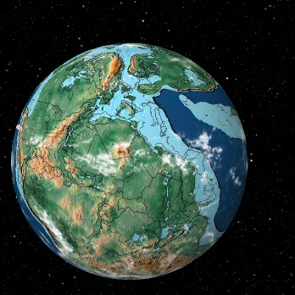  https://dinosaurpictures.org/ancient-earth#0  Please follow @MaltbyGeography on Twitter to keep an eye on more things to do during the holidays.

